

[Node MCU](https://www.factoryforward.com/product/nodemcu-esp8266/) is very popular in-Home **Automation.** It’s Wi-Fi capabilities and Arduino IDE support making it easier for IoT Applications. It is very tiny and has many Digital I/O pins, Serial Communication and I2C Communication. Node MCU has a micro-USB port to program it using your existing mobile cable (no additional programmer needed).

Blynk is a mobile application which has its own server to process user requests. It is an open source application and anybody can use it in their Home Automation to control devices, monitor sensor data and get a notification by some trigger actions. It has a nice GUI with Graphs, Timers, Slider, Joystick and even Video Streaming. You can also make your own app and publish it in Google play store.

**Components required:**

**Hardware:**

* **Node MCU** Development board
* 4 Channel Relay
* USB cable

**Software required:**

* [Blynk App](https://play.google.com/store/apps/details?id=cc.blynk&hl=en)
* [Arduino IDE](https://www.arduino.cc/en/Main/Software)

**Circuit Diagram:**

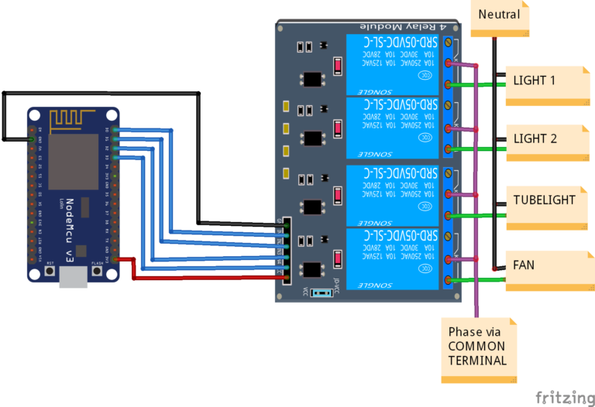

**Node MCU Pinout:**

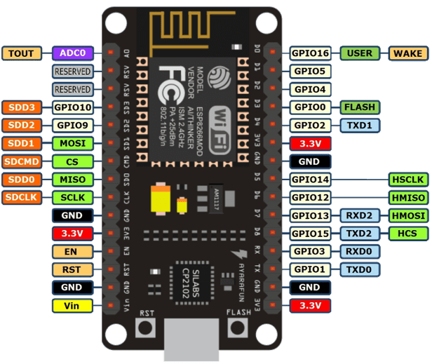

**Download Blynk Application from Google Play store:**

Download and install the Blynk App Here:

[Android](https://play.google.com/store/apps/details?id=cc.blynk&hl=en)

[Apple](https://itunes.apple.com/us/app/blynk-control-arduino-raspberry/id808760481?ls=1&mt=8)

**Create a Blynk App:**

**Step1:** For new users Sign Up and old users just Log in.

**Step2:** Create a New Project and Choose NodeMCU board in the Choose device drop-down and then click create.

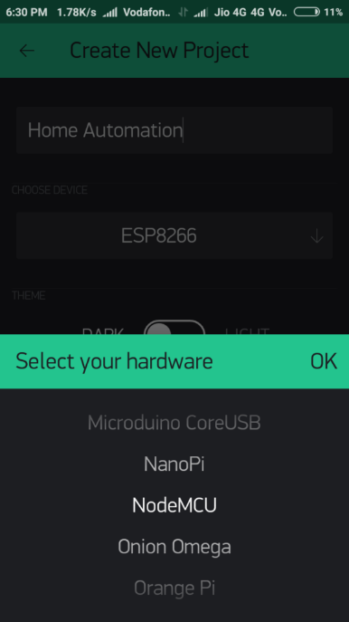 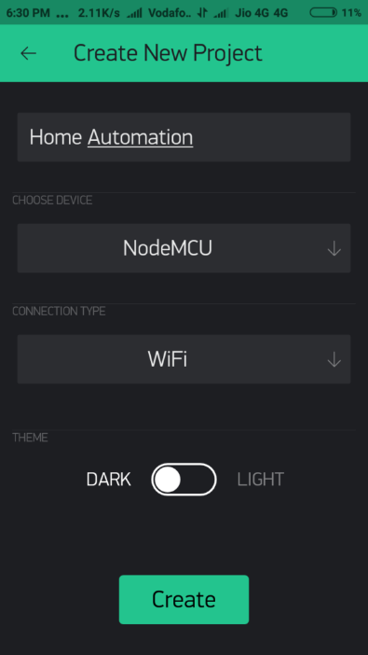

**Step 3:** Now you will receive an email with the Authentication Token. You need to place it in the Arduino Code. Before that, we will finish the App Creation.

**Step 4:** Click on the ‘+’ Icon on the top right corner. Now Widget box will open, We need 4 buttons to control the relay. So add 4 buttons by choosing it here.

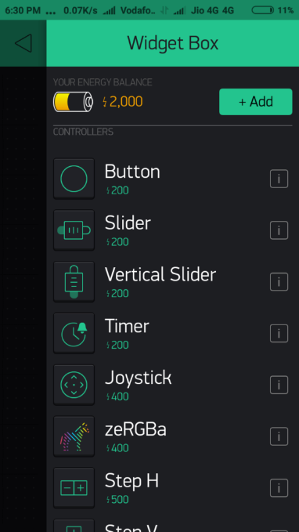

**Step 5:** Now tap on the button from the Homepage to configure it. Choose the Output Pin D0 and Select the Mode as Switch. Then go back. Configure the remaining buttons in the same way.

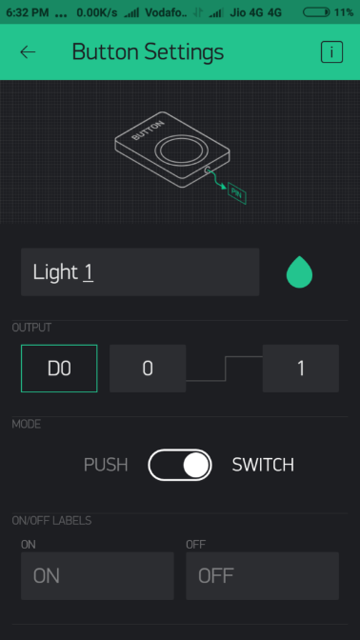

**Step 6:** Now we have the App ready.

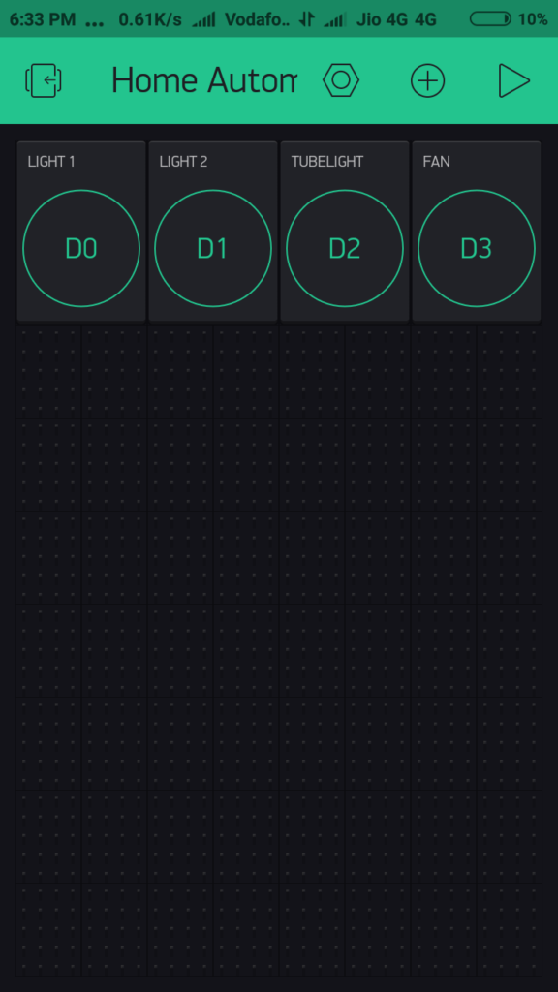

**Codes:**

**#define BLYNK_PRINT Serial**

**#include <ESP8266WiFi.h>**

**#include <BlynkSimpleEsp8266.h>**

**char auth[] = "YourAuthToken";**

**char ssid[] = "Softwarica";**

**char pass[] = "Coventry123";**

**void setup()**

**{**

**Serial.begin(9600);**

**Blynk.begin(auth, ssid, pass);**

**Blynk.syncAll();**

**}**

**void loop()**

**{**

**Blynk.run();**

**}**

Once it completes, Choose the right port and Board then upload the code. That’s it! Your Home Automation Project is ready. You can test it in your Blynk app by turning ON and OFF. It can work from anywhere in the world with an internet connection.

